**PROJECT 3: Design brief**

**Name of Business / Client:** DC Maintenance – Luis Villegas

**Primary Audience:** Businesses (both big and small)

**Secondary Audience:** Homeowners

**Pitch Statement:** Me and my partner are currently attempting to create an informational website that will allow the owner of DC Maintenance, a small and privately own cleaning business, to display what they have to offer in terms of all the services available. The website we are both attempting to provide, will serve as a platform that will display what DC Maintenance is all about by highlighting the business’s mission, goals, etc. Furthermore, the website will be a place where testimonials can be viewed by past clients from those in office work, small parties, and so forth. More importantly, the website will provide as a means of contact, and will include important information such as the phone number, email, address. The website will be simple yet informative and will act as an online business card.

**Tone:** Formal (?)

**Primary CTA:** Users can go to website to see what the company is about and if needed, can call/contact

**Research:** [Rough diagram included on next page] or [Transcribed in text below]

**Why do you need a website?**

I need an information website. Something that will educate my prospective customers on what my company is about, such as what type of cleaning I do and have a price quote is given. Right now I get business via word of mouth and cheaply made flyers.

**What do you need in a website? (be specific and give details on what you want in it)**

I need a home page that has some basic info – phone #, email, what I service, where I service.

**Are there any important aspects that is a MUST on the website?**

Home, About Us, Services, Sanitization Service, Contact.

**Who is the website specifically for?**

It is geared toward the small office owner.

**How will the website help your business?**

The site will help me with exposure. I need to let small building and office owners know about my cleaning service.

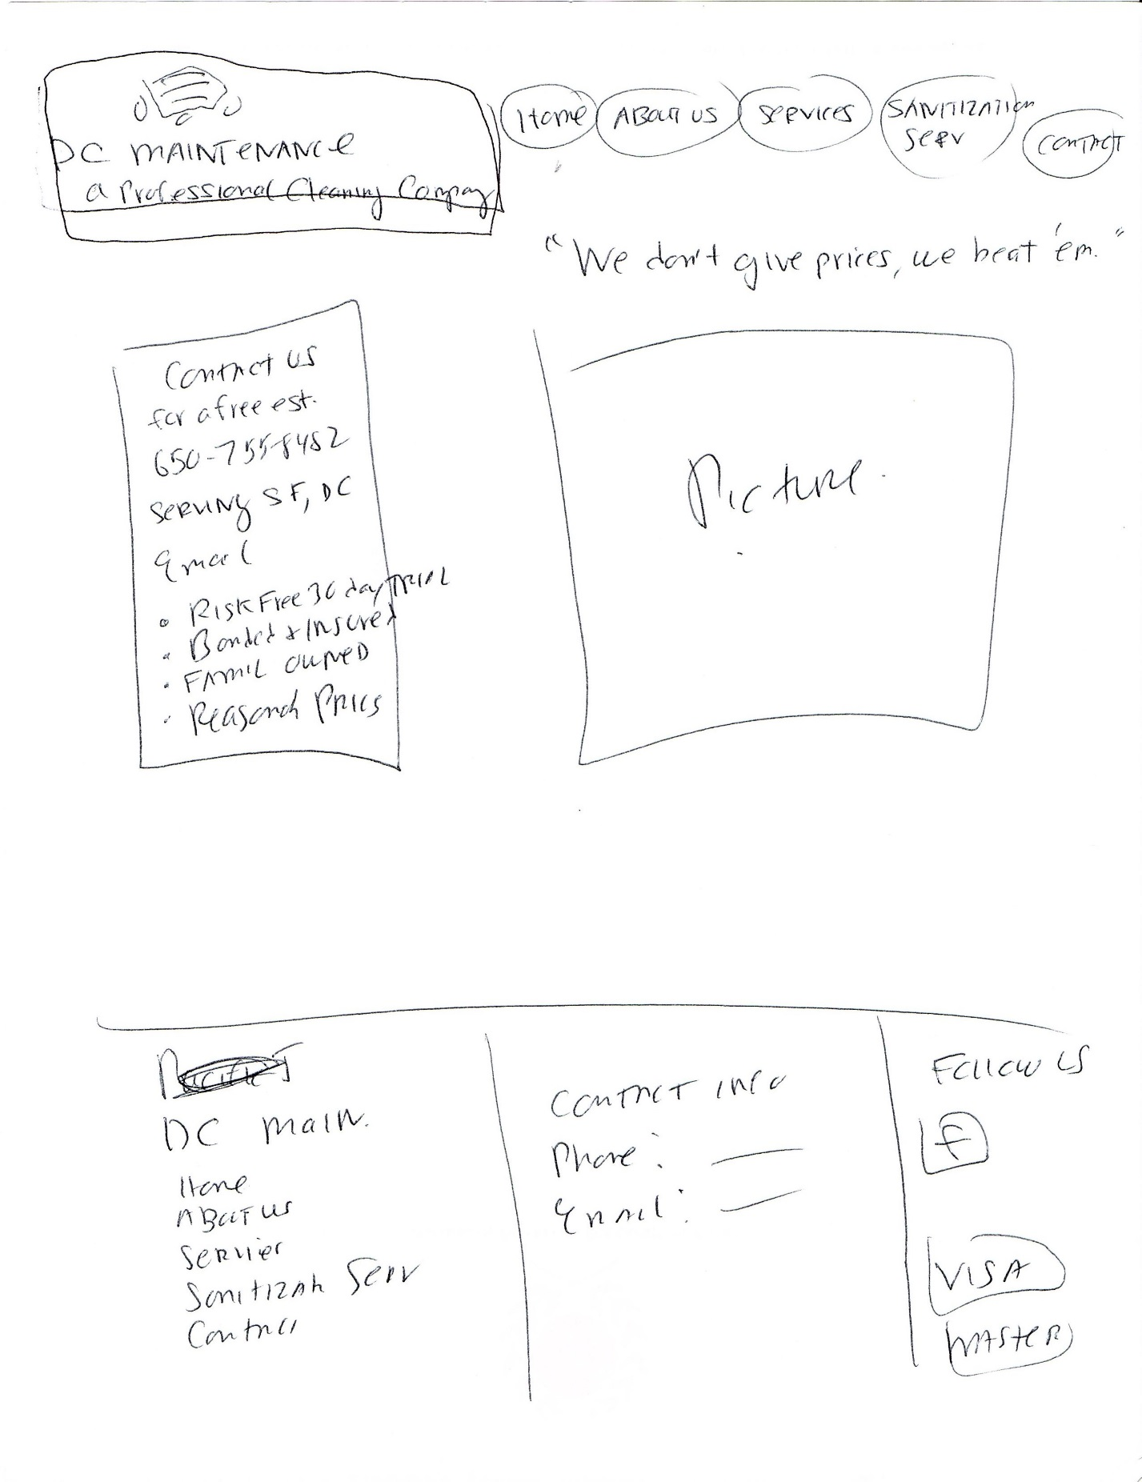[*Early “rough” sketch of website by owner of company*]

[*Prototype of website done in Figma*]